Assignment No:4
Problem Statement: Create a Private Bucket in AWS, upload a file and check by reassign URL whether you can access the file or not.
Solution process:
1. Go to the AWS console and search S3 and click on that.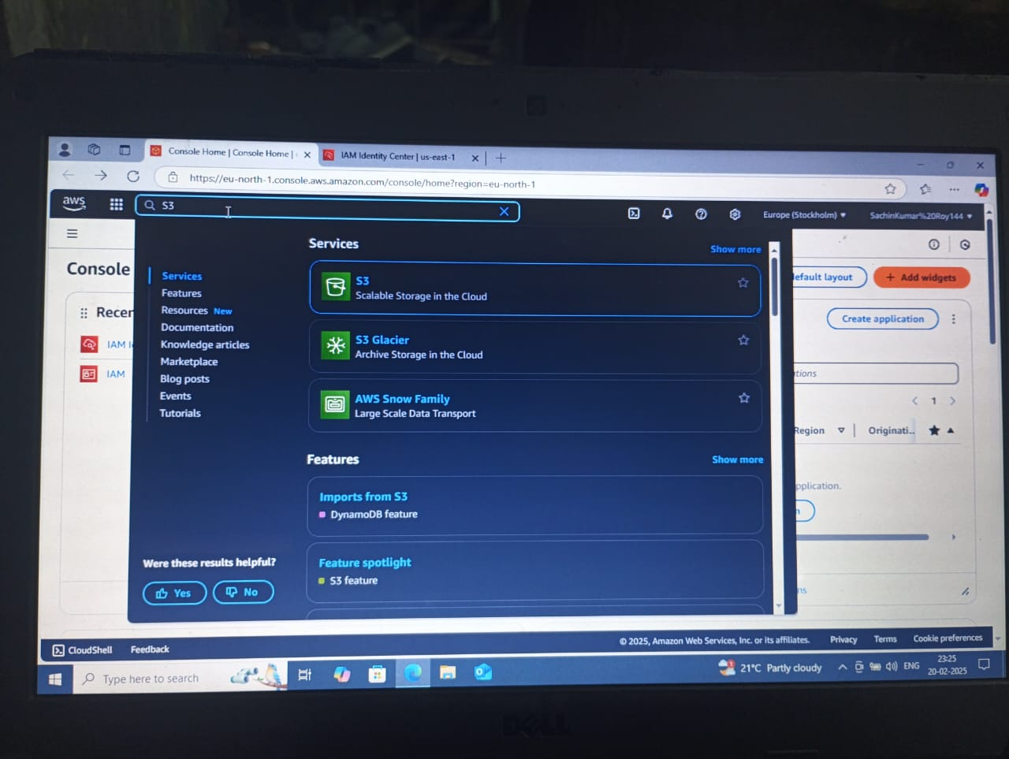
2. Then click on create bucket……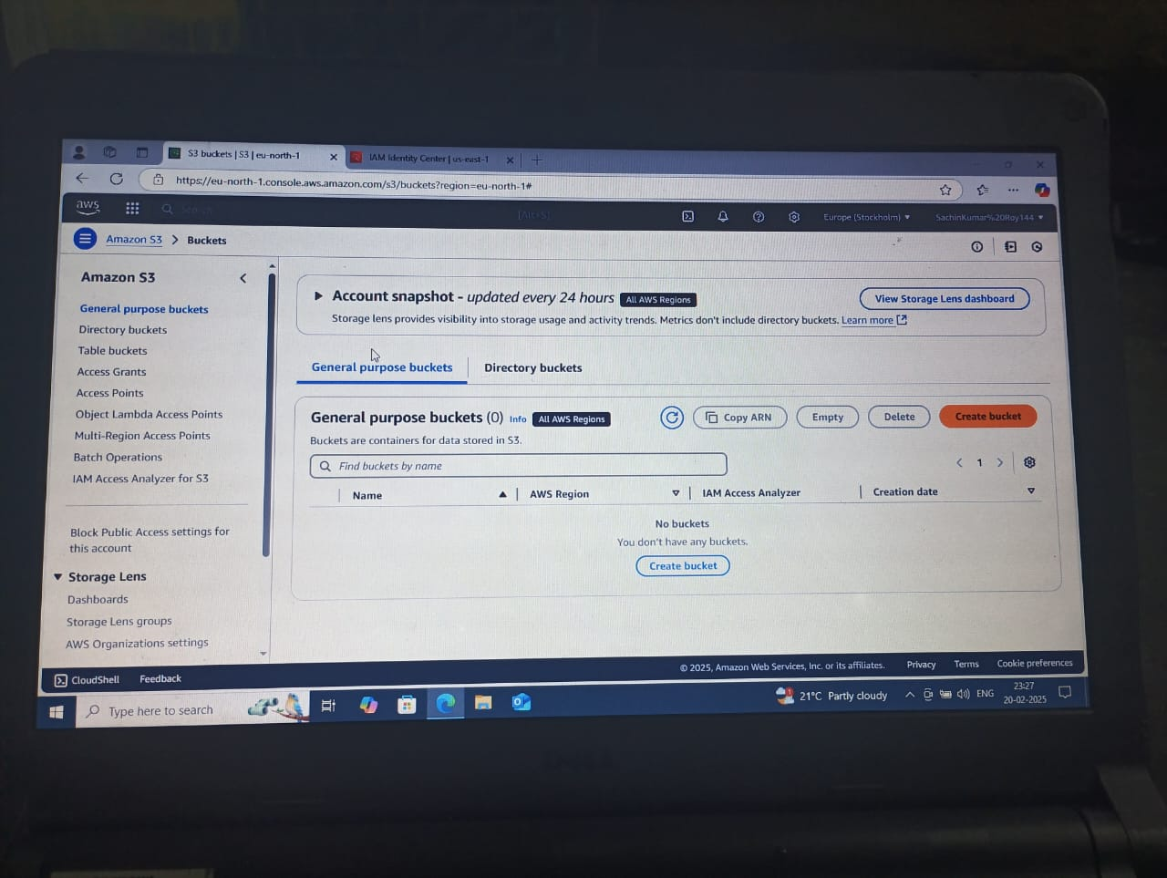
3. Give a unique bucket name and check the Block for all public access.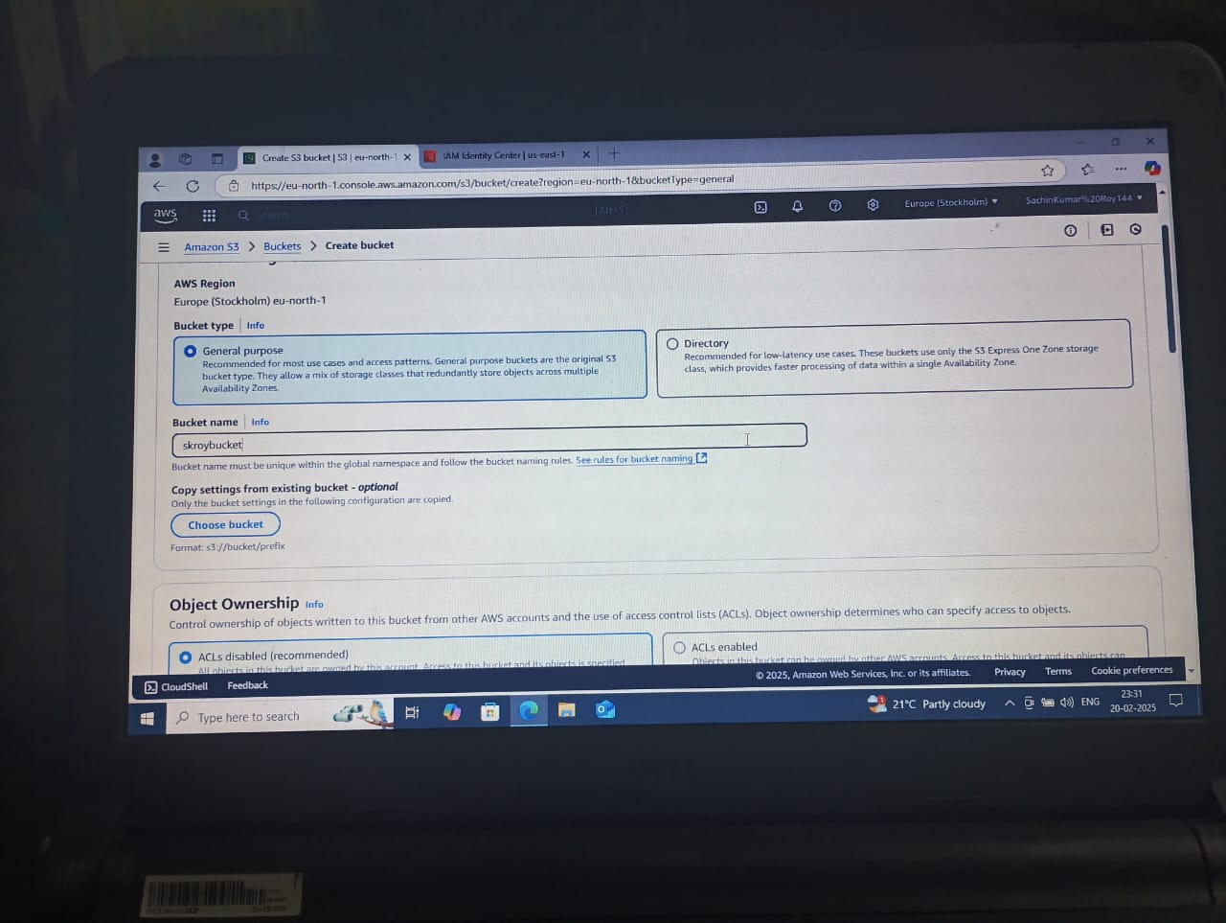

4. After that click on the bucket name.
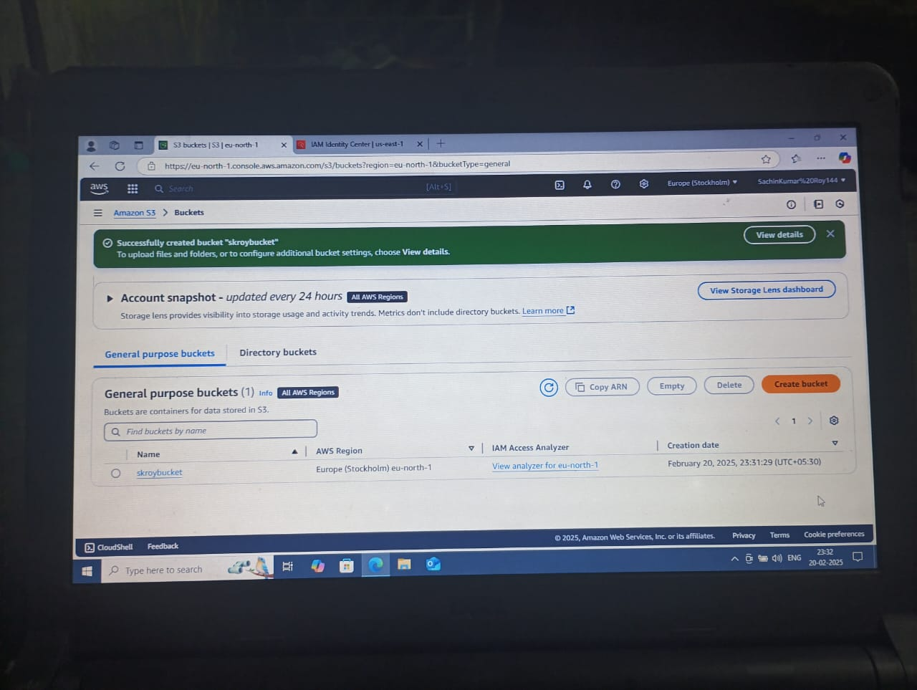
5. Now add files on the bucket. Choose any documents or any picture from your pc and upload that.
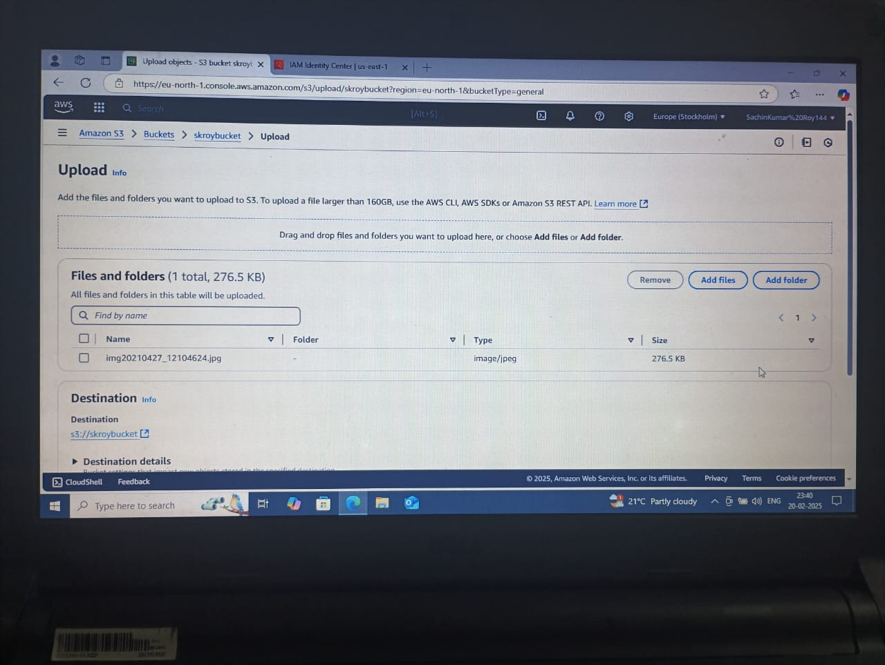
6. After uploading the file, click close on the next page.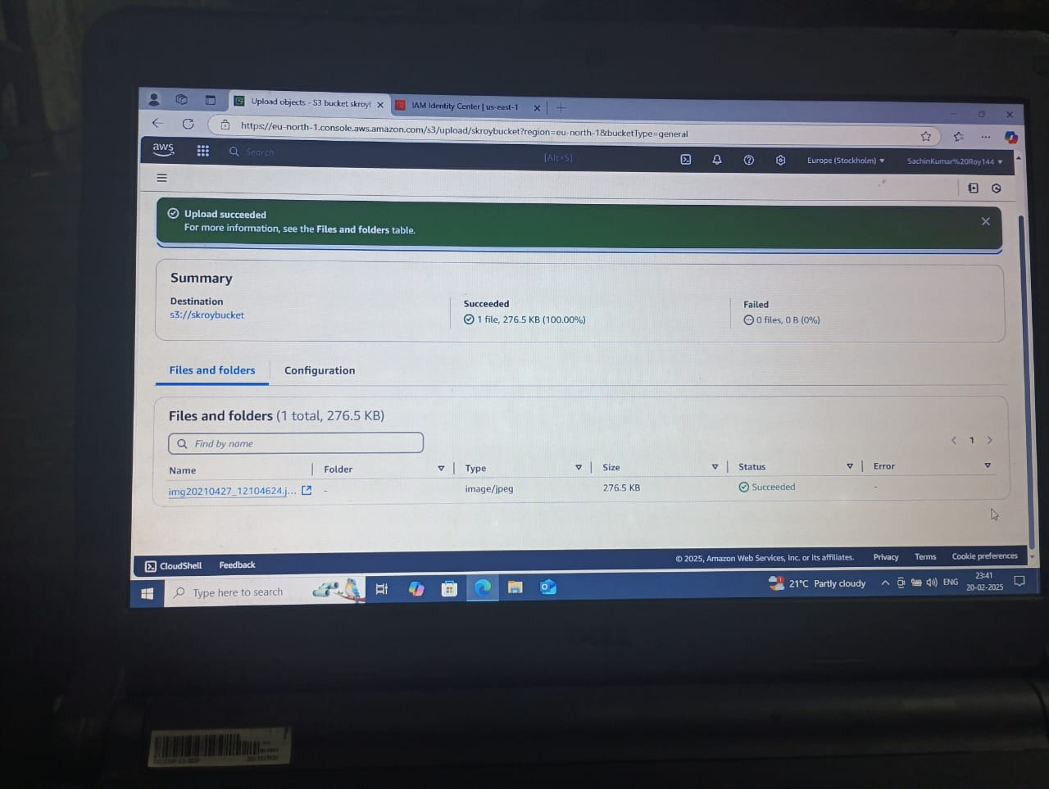
7. Then go to s3 and click the General purpose buckets and click the doc which you
uploaded recently.
8. Then copy the URL of that uploaded doc or files.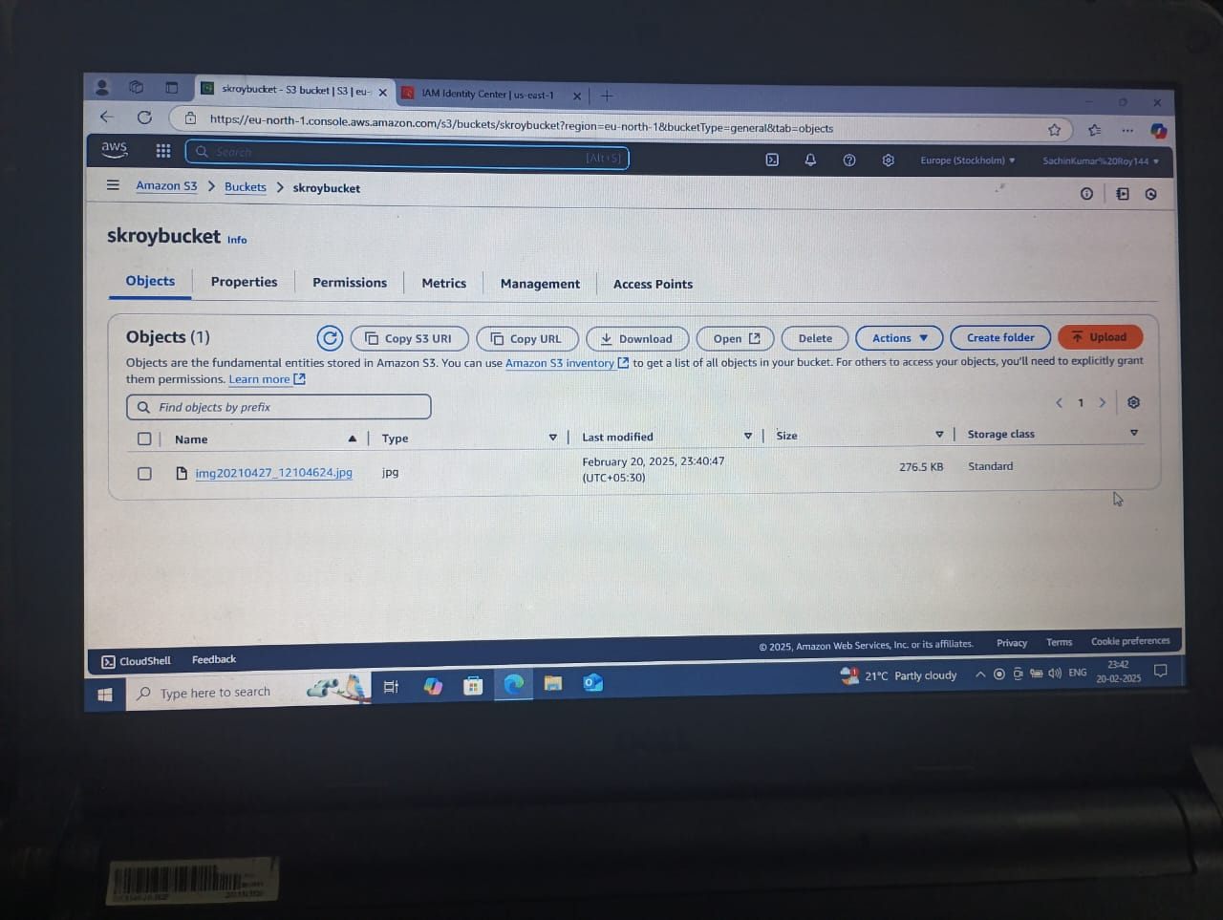
9. Now open an incognito tab and paste the URL and you have permission to deny page.
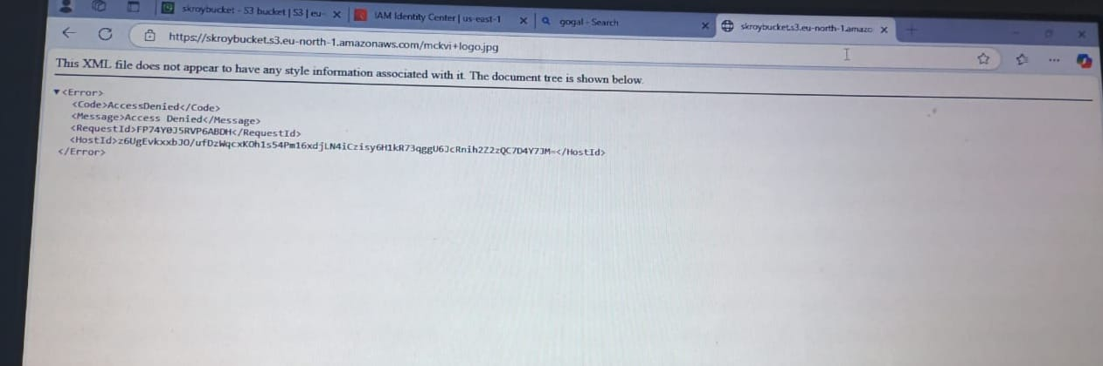
10. Again go back to the main and go for the “Action” option, after clicking on that click on the “Share with a presigned URL” option.
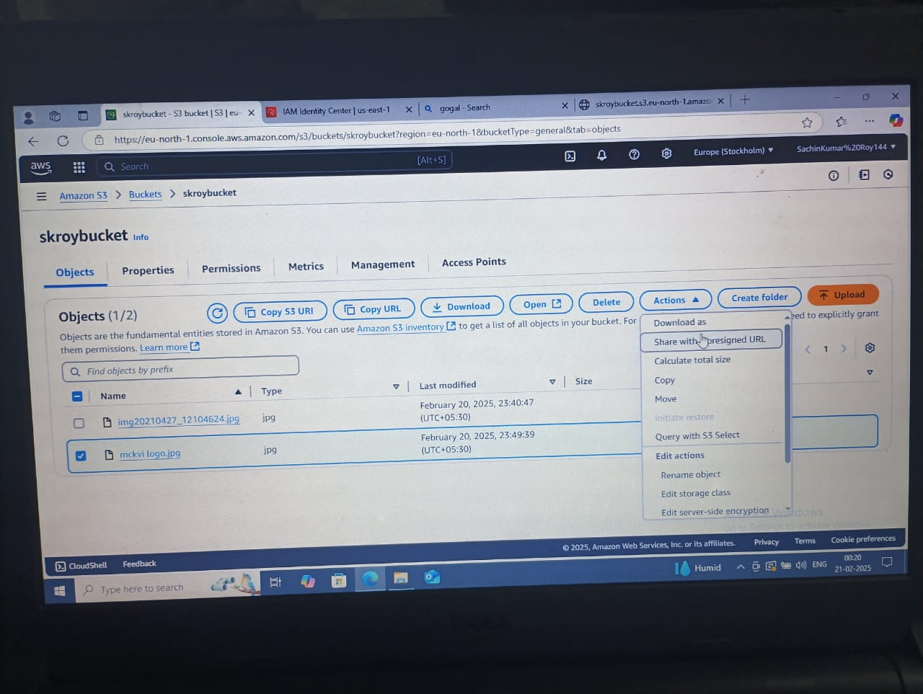
11. Now give a time interval and click on create presigned URL.
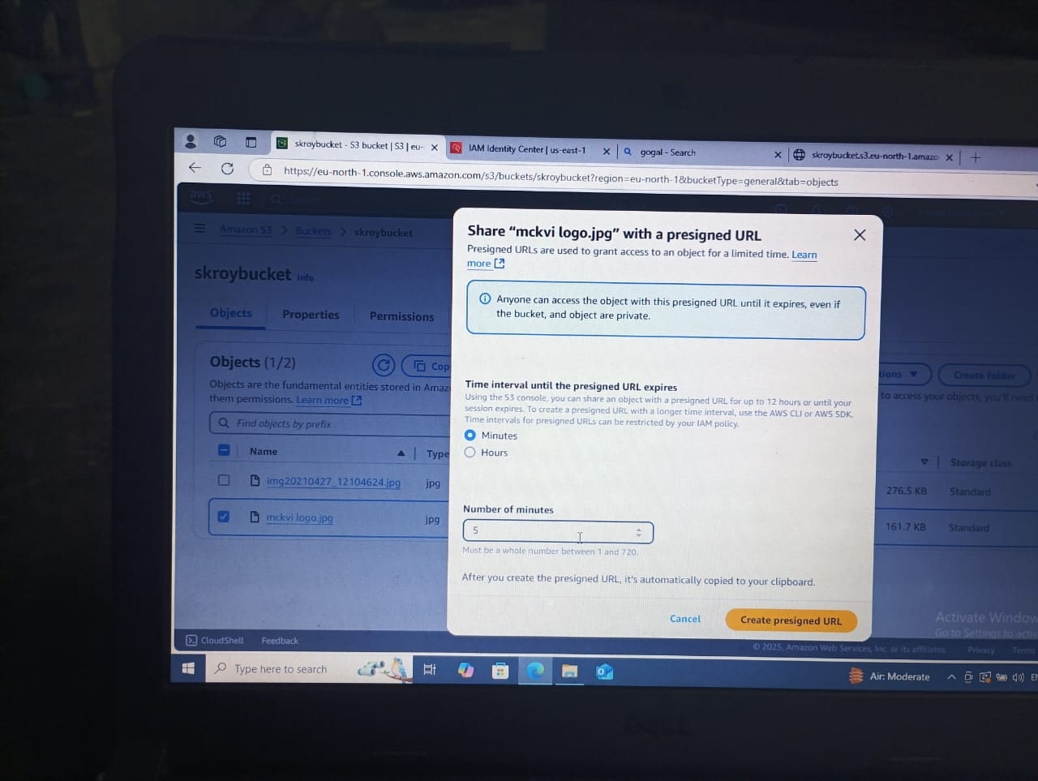
12. Now copy the presigned URL and paste on a new incognito tab and you get the
document that you have uploaded.
